Introduction to Convolution Neural Network

CNN is used for data where we have a gridlike structure (time-series data and images).
CNN consists of a Convolution layer, pooling layer and one or more fully connected dense layers.
Some applications of CNN are:
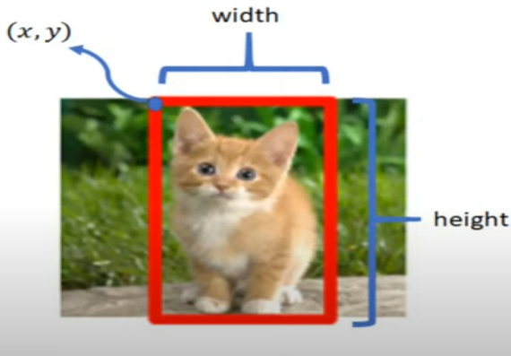
- Object localization: In a given image, where a particular object is, it create a rectangle around that object.

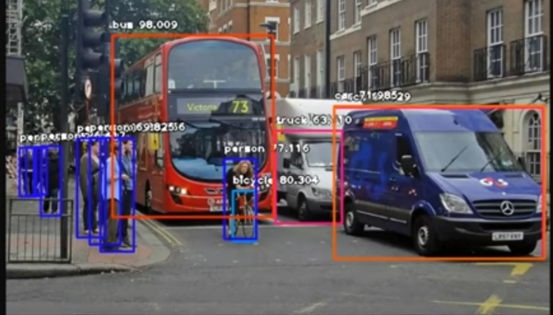
- Object detection: Used in self driving cars. It not only finds all the objects in an image but also locates them by drawing a rectangle around those objects and also gives the probability for objects like if there is a bus in an image, it detects the bus, draws a rectangle around it and also gives a probability for being a bus.

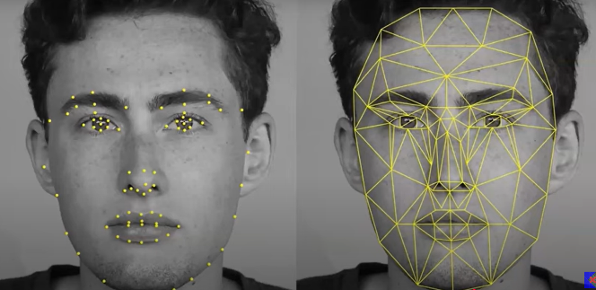
- Face Detection and Recognition: We all have used it. The face lock in our mobile uses this technique.

- Increasing the resolution of images with low resolution.
- Converting b&w images to color: Some old b&w movies converted to color.

